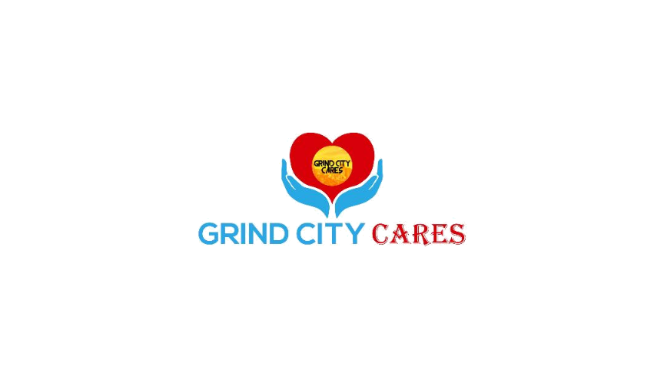

Introduction to Grind City Cares
Grind City Cares was established with the hope of providing substantial resources and creating solutions for communities facing significant challenges. Our core mission is to impact as many lives as possible by providing essential resources, creating solutions to pervasive social issues, and establishing opportunities for aid to both individuals and families.

Highlighting a Critical Need: Perinatal Awareness
This year, Grind City Cares is dedicated to bringing awareness to perinatal care. This focus was inspired by the personal journey of the Onwuka family. They experienced firsthand the challenge of their twin daughter requiring continuous, dependent care through a feeding tube for 80 days. The support they received from healthcare professionals, family, and friends motivated them to extend that same encouragement and aid to others.
Through connecting with other families, the founders recognized a widespread need for both educational awareness and support for perinatal challenges.

Join the Movement: The Midsouth Race
To address this need, we will host the Midsouth Race for Perinatal Awareness on June 6, 2026, at Shelby Farms Park, Hyde Lake, in Memphis, TN. The event will serve as a platform to educate the community and spotlight the crucial work of organizations that provide care to mothers, babies, and their families.

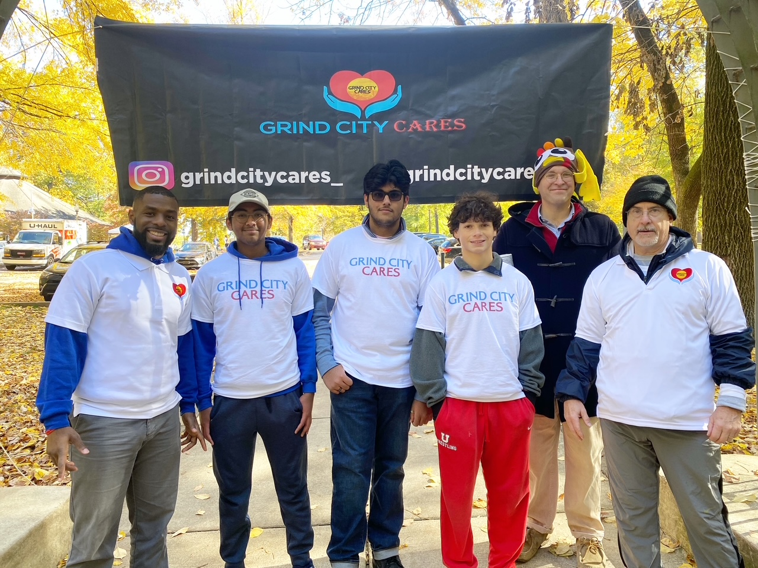

Impact Statement
Perinatal challenges affect countless families across the Mid-South, with premature births and maternal health disparities creating long-term hardships. The Midsouth Race for Perinatal Awareness will directly support mothers, babies, and families by raising funds for care packages, medical support, and emergency relief. By partnering with us, sponsors will be fueling real change, helping ensure that families in Memphis have the resources they need during their most critical moments.

Audience Reach
- Participants: Anticipated 500+ runners and walkers.
- Total Event Attendance: Over 1,500 individuals including families, volunteers, vendors, and community supporters.
- Digital Reach: Social media campaigns, email marketing to 2,500+ contacts, and community partner networks.
- Demographics: Young families, healthcare professionals, students, and community advocates invested in maternal and infant health.

Marketing & Media Exposure
Grind City Cares has previously been featured on platforms including local Memphis news outlets, social media networks, and community publications. Sponsors will receive visibility through:
- Logos on marketing and promotional items and digital materials.
- Mentions in press releases, social media campaigns, and race-day announcements.
- Highlighted in post-event thank-you campaigns that demonstrate sponsor impact.

Potential Community Partnerships
We plan to engage key organizations that serve mothers, infants, and families, including:
- Le Bonheur Children’s Hospital
- Regional One Health’s Maternal Services
- Shelby County Health Department – Healthy Start & Baby Café programs
- Baptist Women’s Hospital
- Birthright of Memphis
- Catholic Charities of West TN
- Volunteer Odyssey and other community volunteer networks

Success Story
In the past, Grind City Cares has hosted a Thanksgiving 5K to serve families in the MAM community. Thanks to sponsors, volunteers, and partners, we were able to feed over 100 families with full holiday meals. This success highlighted our ability to organize impactful events that transform sponsor contributions into tangible community benefits.

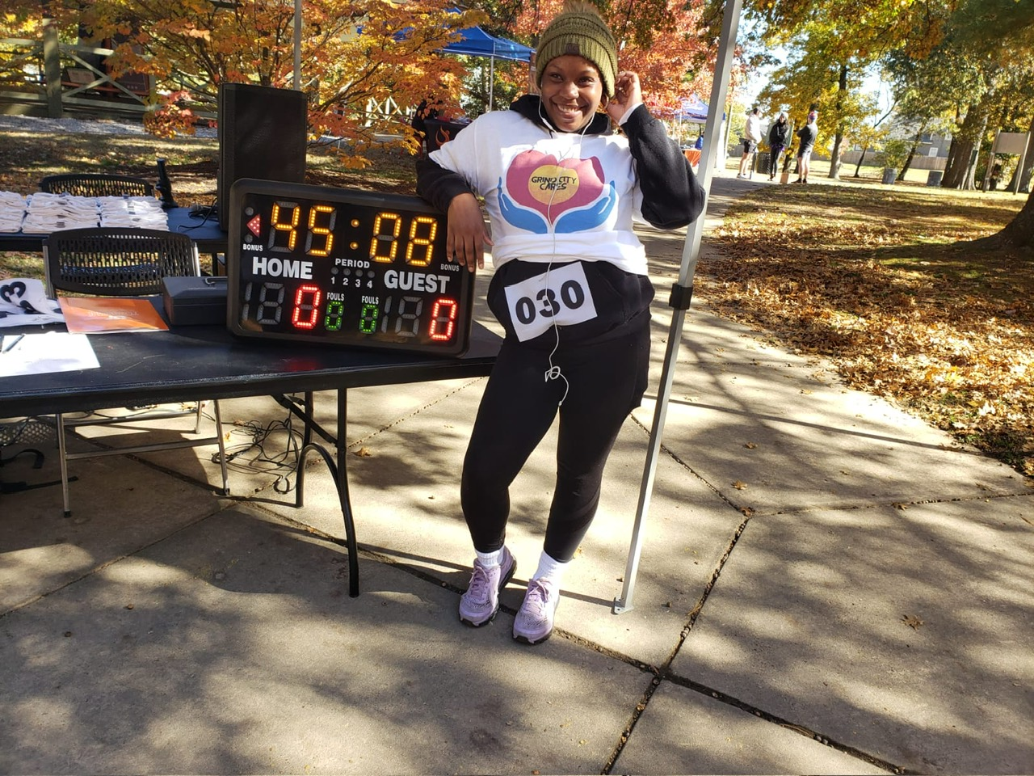

Call to Action
Join us in making the Midsouth Race for Perinatal Awareness a milestone event for Memphis. With your sponsorship, we can bring hope, resources, and life-changing support to hundreds of families facing perinatal challenges. Together, we can ensure that no mother or child walks this journey alone.

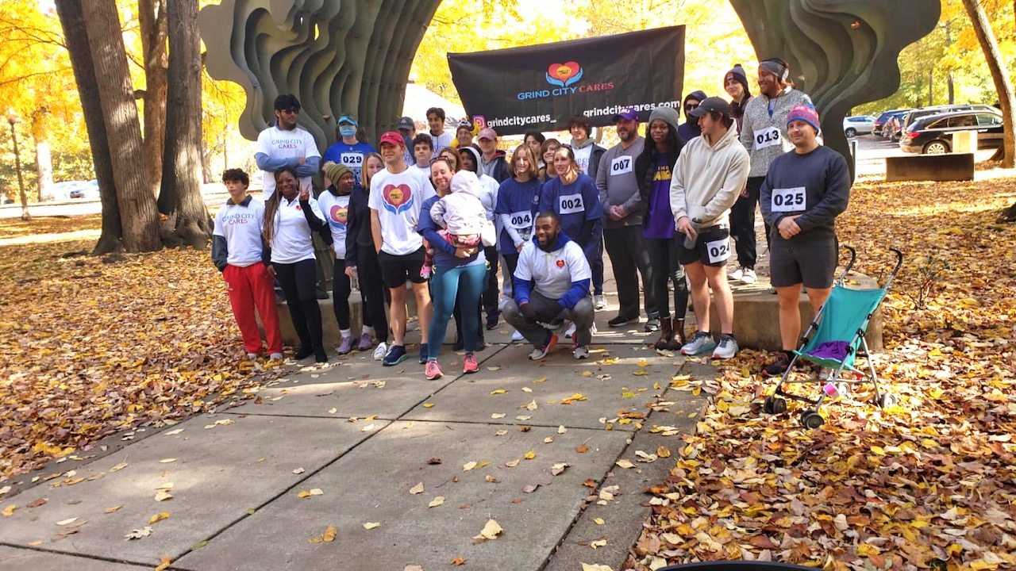

Sponsorship Tiers
Tier | Contribution | Benefits
Title Sponsor | $15,000 | - Naming rights (“[Sponsor Name] presents the Midsouth Race for Perinatal Awareness”)  - Exclusive vendor space at the event  - Logo on all race materials, banners, and shirts  - Prominent placement on website and social media  - Press release announcement  - Featured in TV, news, and radio coverage  - VIP table at race-day events  - Opportunity for speaking engagement at race  - 20 free race tickets
Platinum Sponsor | $10,000 | - Exclusive vendor space at the event  - Logo on race materials, banners, and shirts  - Website and social media recognition  - Press release announcement  - Featured in TV, news, and radio coverage  - VIP access at race  - 15 free race tickets
Gold Sponsor | $7,500 | - Logo on race banners and shirts  - Website and social media recognition  - Press release announcement  - Featured in select news and radio coverage  - VIP access at race  - 10 free race tickets
Silver Sponsor | $5,000 | - Logo on race banners  - Website recognition  - VIP access at race  - Optional news mention  - 6 free race tickets
Bronze Sponsor | $2,500 | - Logo on select race materials  - Website recognition  - 4 free race tickets
Community Sponsor | $1,000 | - Recognition on website and social media  - Thank-you acknowledgment at the race  - 2 free race tickets

THANK YOU FOR YOUR SUPPORT

Name: ____________________________________________
Email:______________________________________________
Phone:_____________________________________________
Company/Organzation:___________________________________
Level of Commitment: _____________________________________
Make checks payable to:
Grind City Cares
2095 Exeter Rd
Germantown TN 38138
Suite 80, P.O. 396

Contact us for additional information or questions,
Chima Onwuka | CEO, Grind City Cares
grindcitycares@gmail.com

